**CS-359 Assignment-11**

Name: P. V. Sriram

Roll No.: 1801CS37

In this assignment, we experimented with various statistical values which related to the performance of Internet Protocols like Throughput, Round trip time, Packet Size, Number of packets lost, Number of TCP, UDP Packets, Number of responses with respect to requests etc.

For this purpose, we captured data packets from and to facebook.com at two different parts of the day. And on this data, we applied various functionalities of Wireshark to analyze performance.

# Capturing Packets

1. Firstly, we need the IP address of Facebook.com to apply capture filter.
2. We can do so by using the ping facebook.com command
3. We can also find out our own IP address using the ifconfig command
4. Facebook => 69.171.250.35
5. PC => 10.0.2.15
6. After we have this data, we can use capture filter as host 69.171.250.35 and then start capturing
7. Open a tab and go to facebook.com and perform actions until at least 2000 packets.

# Throughput

Throughput tells you how much data was transferred from a source at any given time and bandwidth tells you how much data could theoretically be transferred from a source at any given time.

We can measure average throughput and graphical plot of throughputs of various packets using Wireshark

For summary of transfers, got to **“Statistics -> Capture File Properties”**

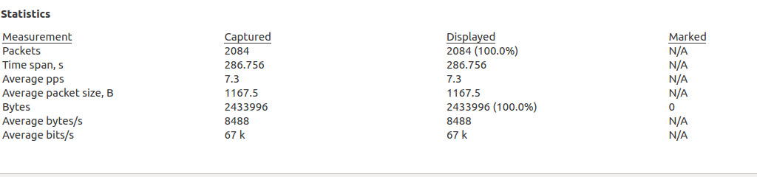

The above picture shows that Average rate of transfer in **bits/sec is 67k.** Which is average throughput

We can also view the distribution of Throughputs of various packets going coming from Facebook to the machine.

We can do this by **“Statistics -> TCP Stream Graphs -> Throughput”**

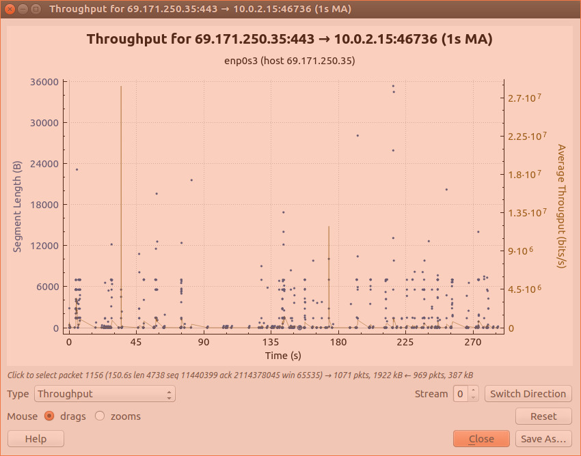

We can see in the above graph that there are a lot of spikes in speeds varying from 10^6 range to 10^7

We can also view at packets going from machine to Facebook by switching directions

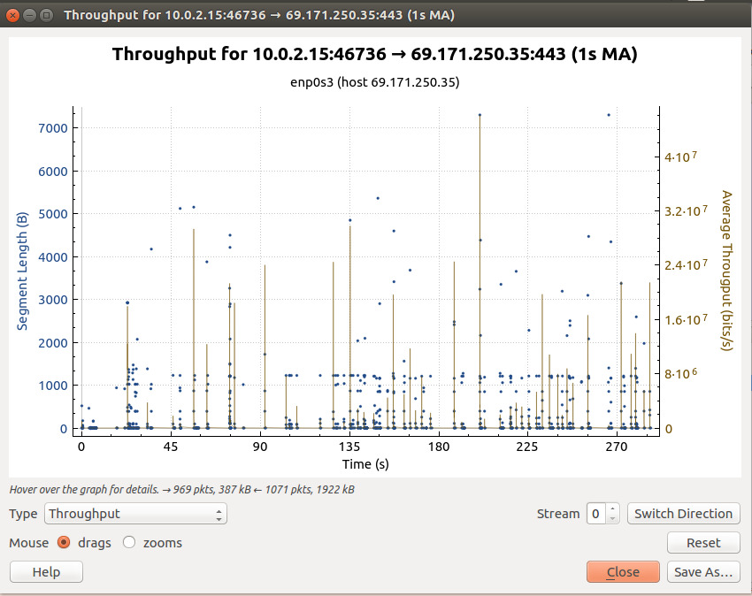

Similarly, we can repeat the experiment at another duration of the day. The following are the results.

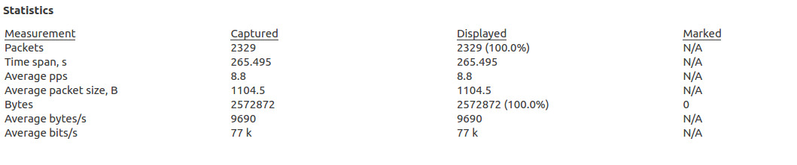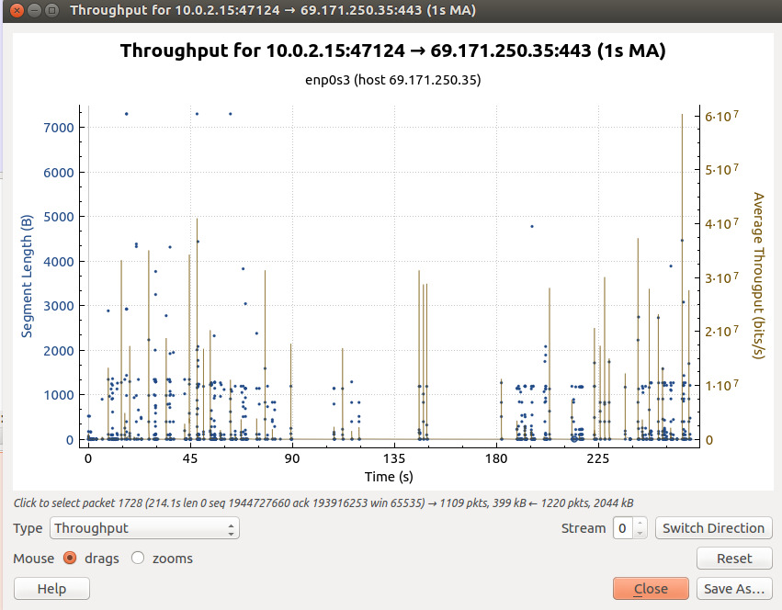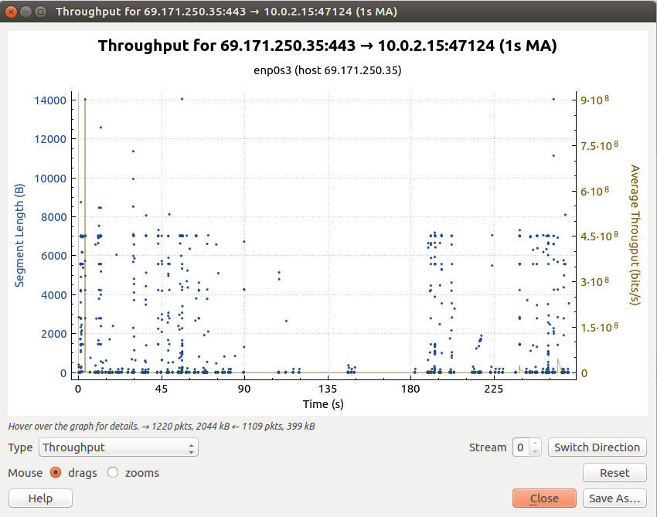

# Round Trip Time

Round Trip Time (RTT) is the length time it takes for a data packet to be sent to a destination plus the time it takes for an acknowledgment of that packet to be received back at the origin.

It Is possible to plot the graphs similar to those of throughputs for to and fro packets in Wireshark.

We can do so by **“Statistics -> TCP Stream Graphs -> Round Trip Time”**

The following graph plots the RTT of packets going from machine to facebook. We can see they vary between 0.1ms to 7 ms with major chunk lying from 0 to 2.

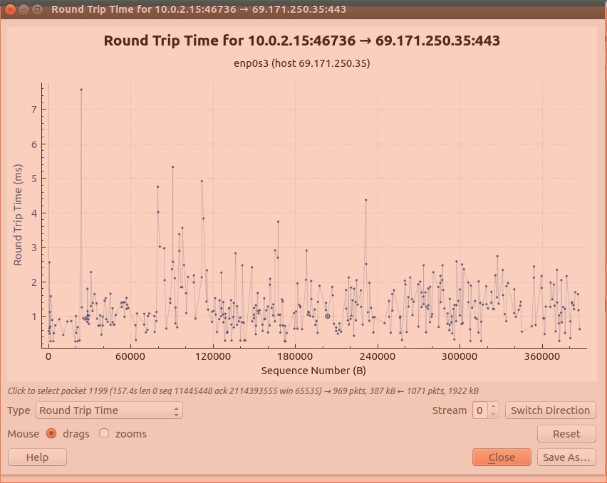

The packets coming from Facebook have very less RTT. Because of the high speed servers of Facebook and the acknowledgement is also sent immediately from our machine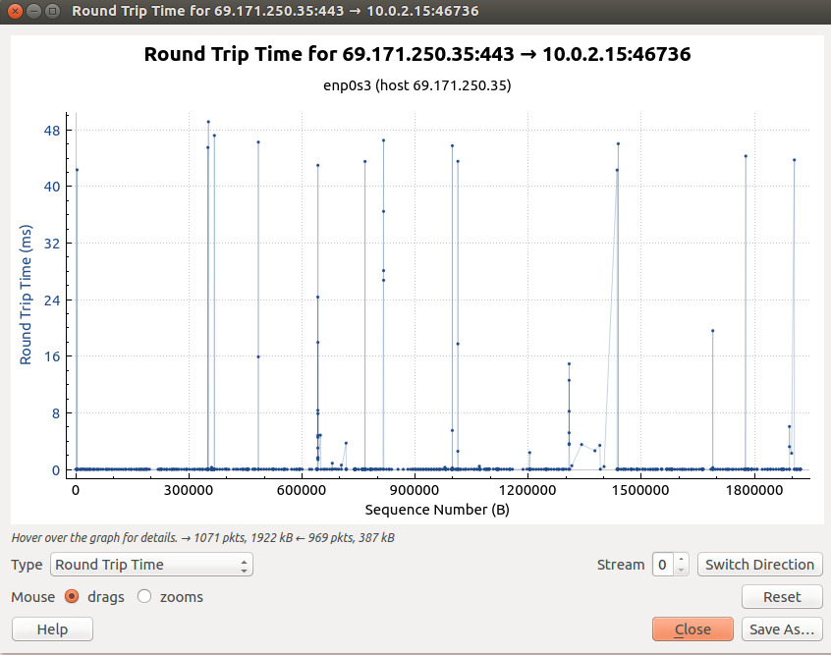

Similar experiment could be replicated at another time of the day by performing same steps.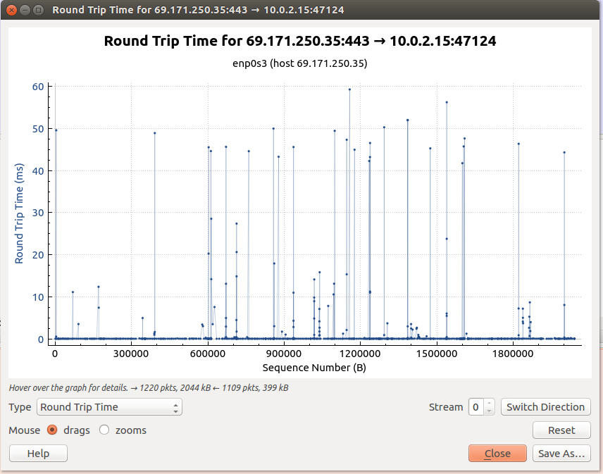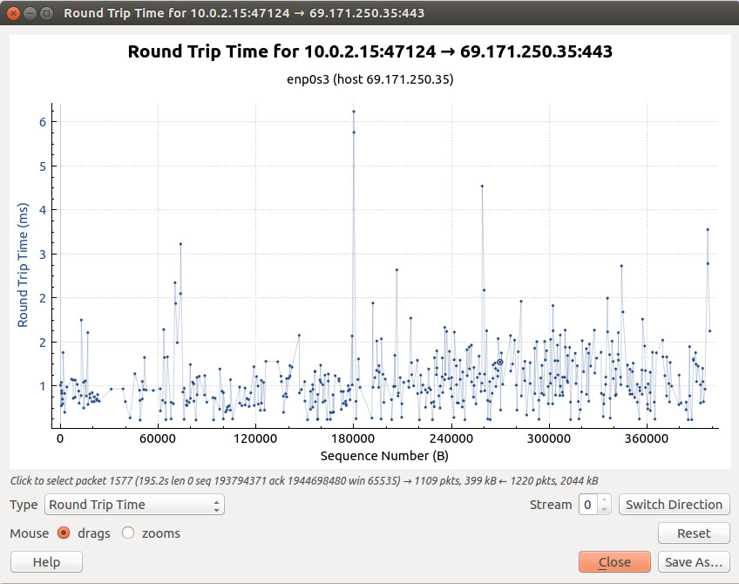

# Packet Length

The summary of amount of data carried by packets can be displayed using **“Statistics -> Packet lengths”**

Following are the results for data collected at different times

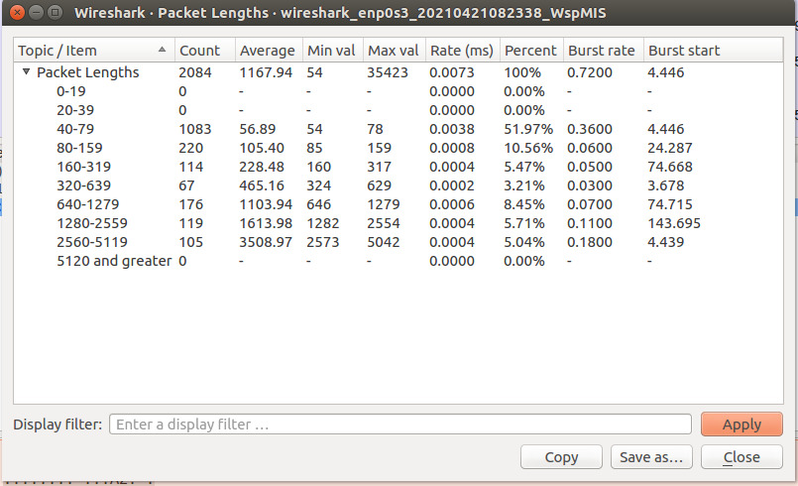

In the above data, we can see the average length of packet is 1167.94 bytes

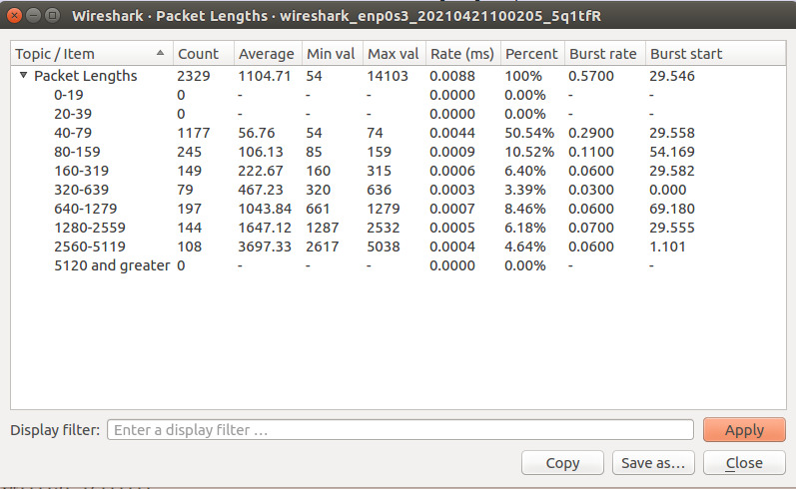

In the above data, we can see the average length of packet is 1104.71 bytes

# Packets Lost

We can check the number of packets lost using the **“Statistics -> Capture File Properties”**

The summary shows many details including Dropped packets.

Luckily, due to the reliable Facebook servers, we get 0 dropped packets.



# TCP Packets

Since Facebook Only uses TCP Protocol, there isn’t much use of data from only Facebook. Therefore for the experiment of Capturing TCP Packets and UDP Packets, we remove the capture filter and collect general data.

We can use the Display filter **“tcp”** to view at only TCP Packets.

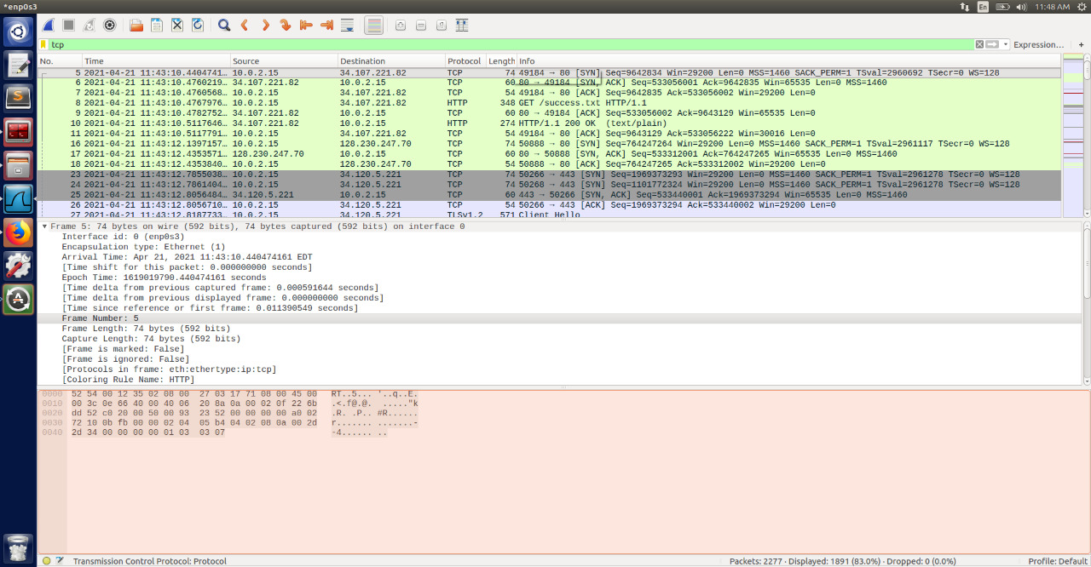

We can see that 1891 packets out of 2277 captured packets are TCP protocol.

i.e. 83% of packets follow TCP protocol.

# UDP Packets

Similarly, we can capture the UDP Packets using the display filter **“udp”**

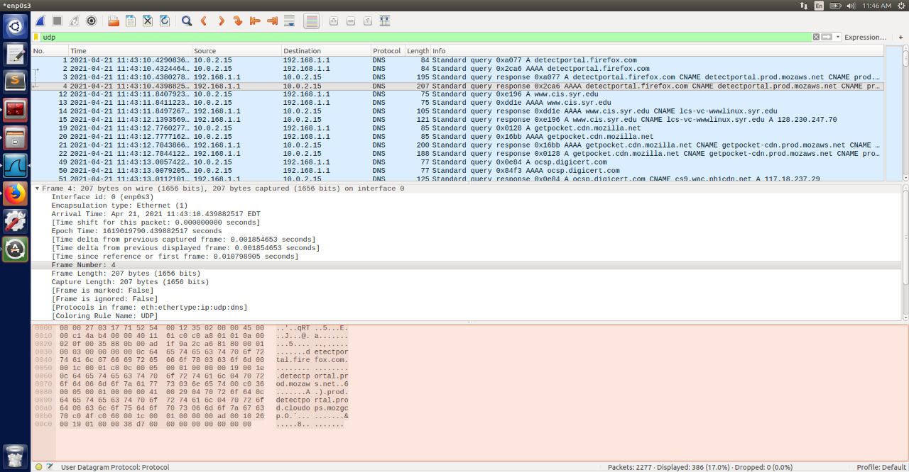

We can see that 386 packets (17% of packets) out of 2277 packets follow UDP Protocol.

# Request-Response

As a part of this experiment, we are also required to capture Request Response pairs. i.e. How many Responses would be there for one particular Request.

Therefore, we need HTTP GET data. Unfortunately, Facebook follows HTTPS protocol, and therefore we need to change our source for this experiment. A website which uses HTTP is essential.

For this experiment, we use a site bio.accousti.ca. IP address is 157.140.2.239. We can capture its data using **“host 157.140.2.239”** capture filter.

Now that we have the data, we need to perform the following steps to capture its response packets

1. From the data, display the request packets using **“http.request”** display filter
2. From the resulting list, choose one random request and display it. I have used “http.request.uri contains "/misc/arrow-desc.png"” for this experiment.

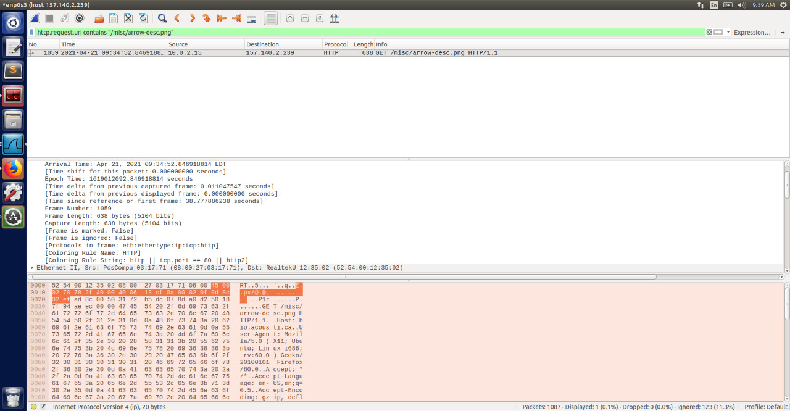

1. Next step involves removing all the other requests and their responses. This could be done using **“http.request && !http.request.uri contains "/misc/arrow-desc.png"”** display filter and remove that list using **“Edit -> Ignore all displayed”**
2. Now there is only the response for the request we are considering. We can display the response using **“http.request_in”** display filter

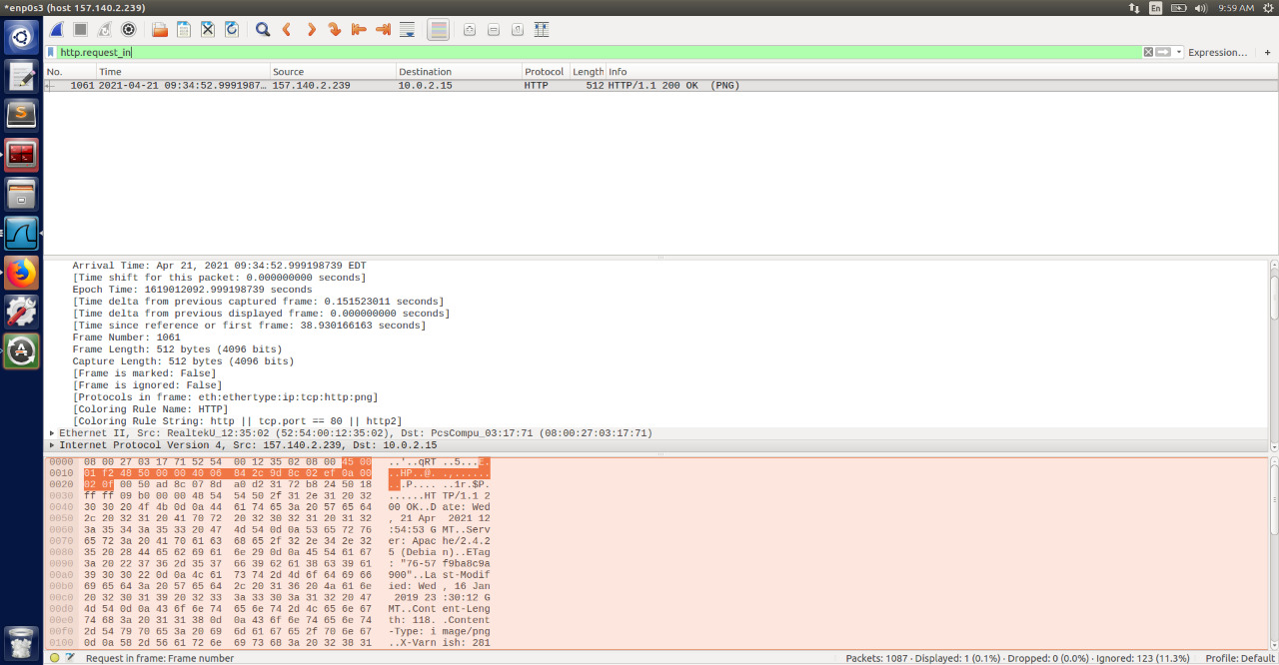

We can now see the singular response for our request.